**Git:[versional control systems]**

version control system is nothing taking backup of data with timestamp before and archieving them and give them whenever we needed

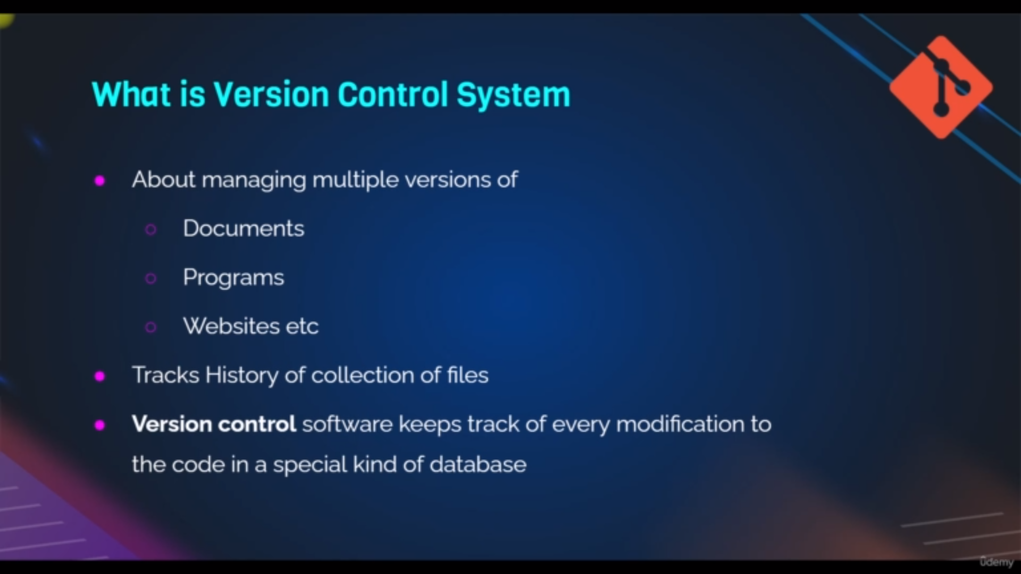definintion of versional control system

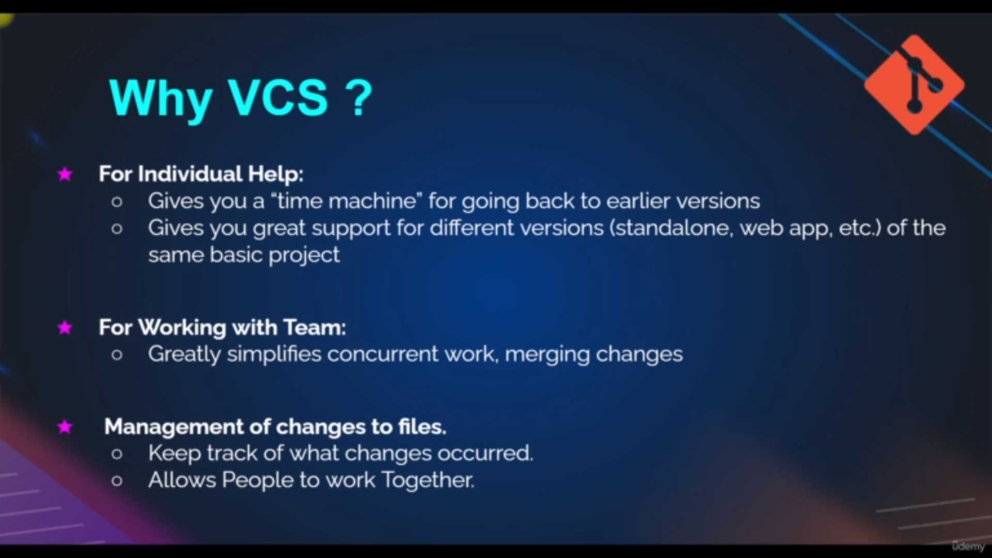uses of vcs

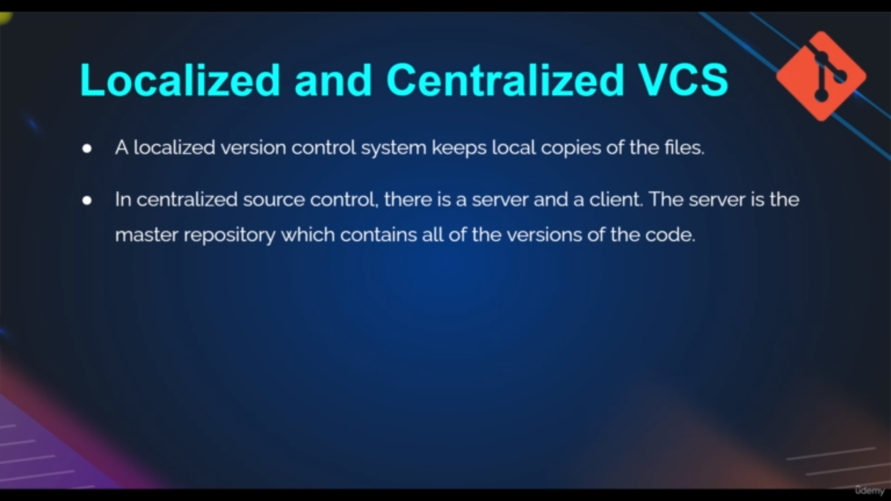types of vcs

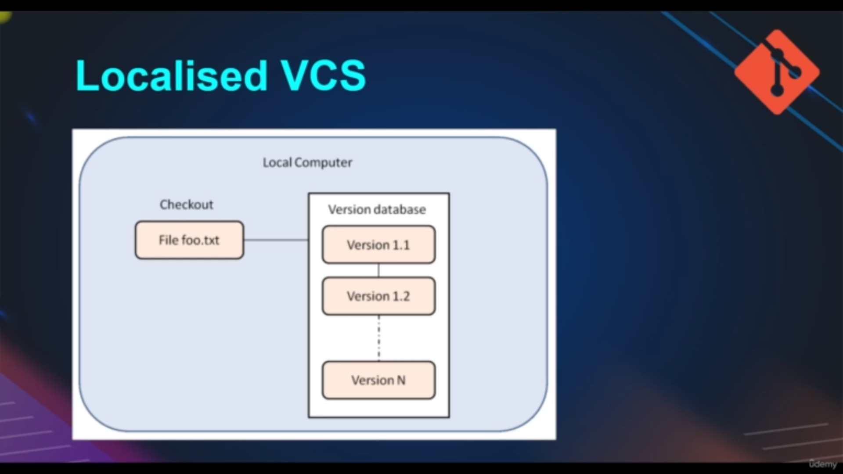independent user independent ,central repositery

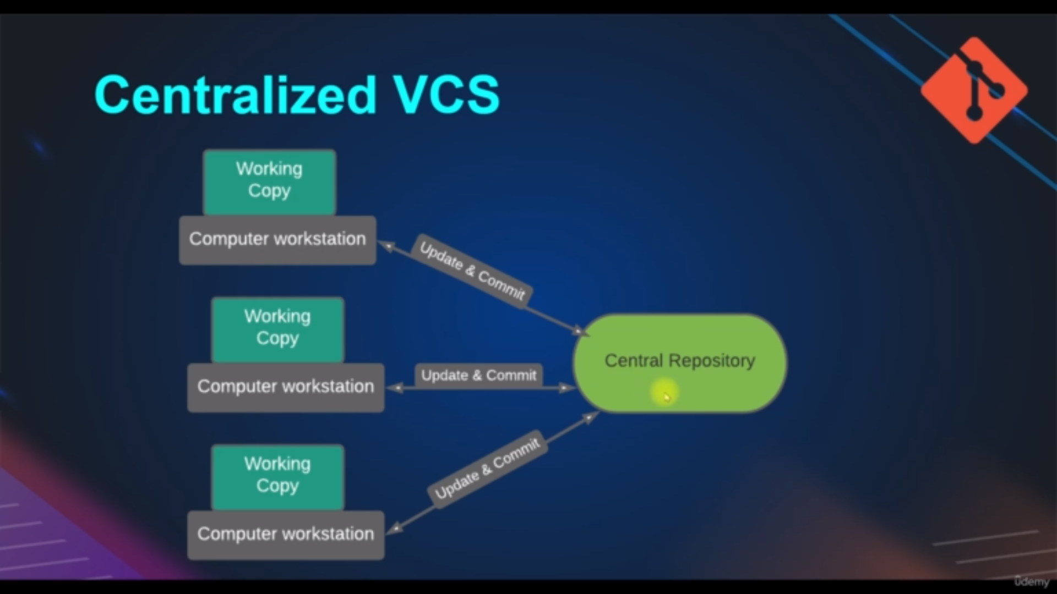multiple user and one centralized repositery

In this we have working copy there we changes and push it to the central repositery

multiple changes from multiple user cannot be possible

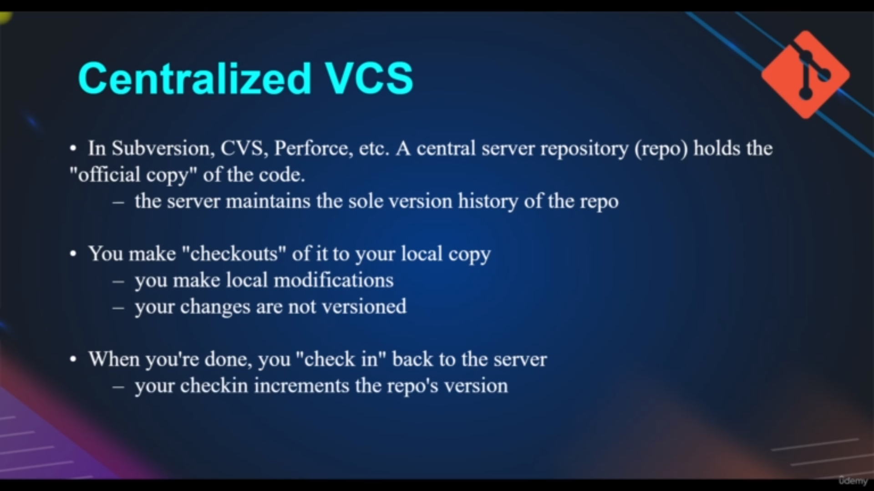uses of cvs

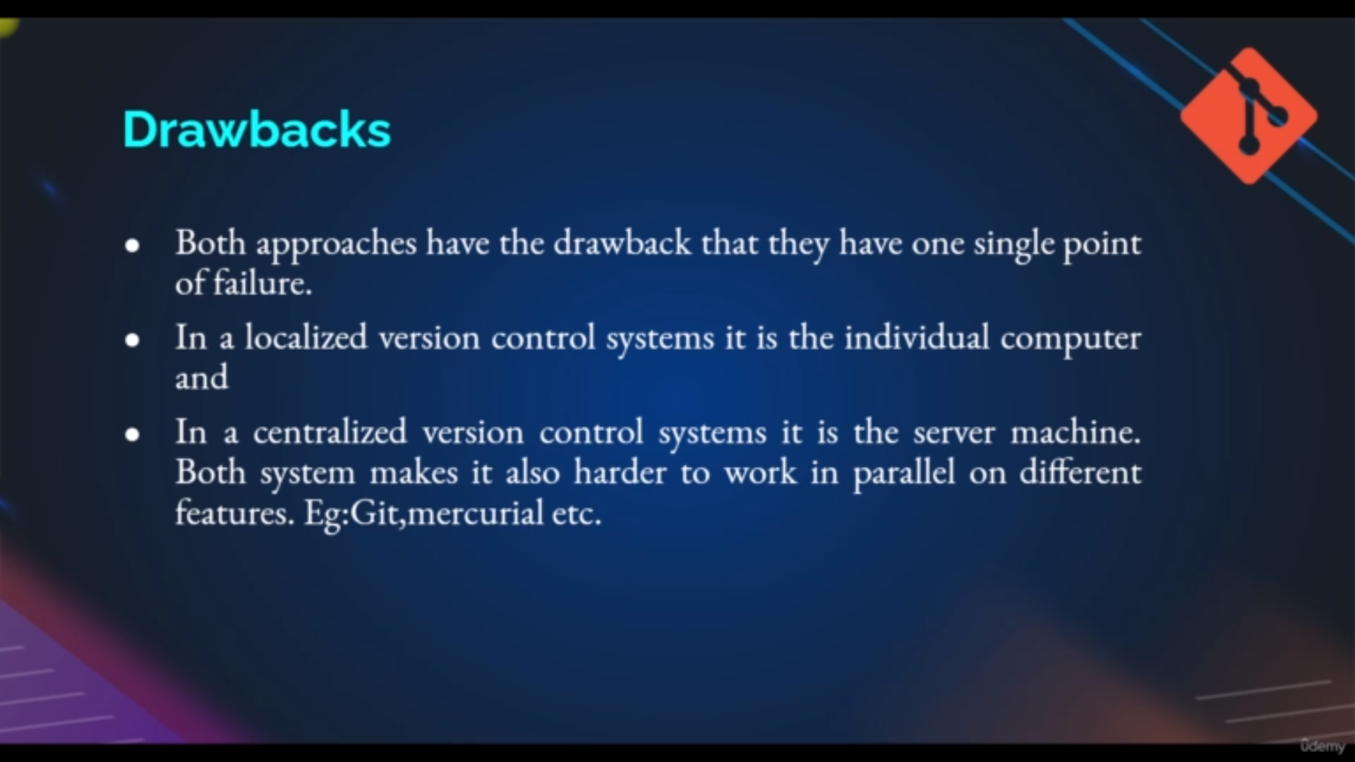drawbacks

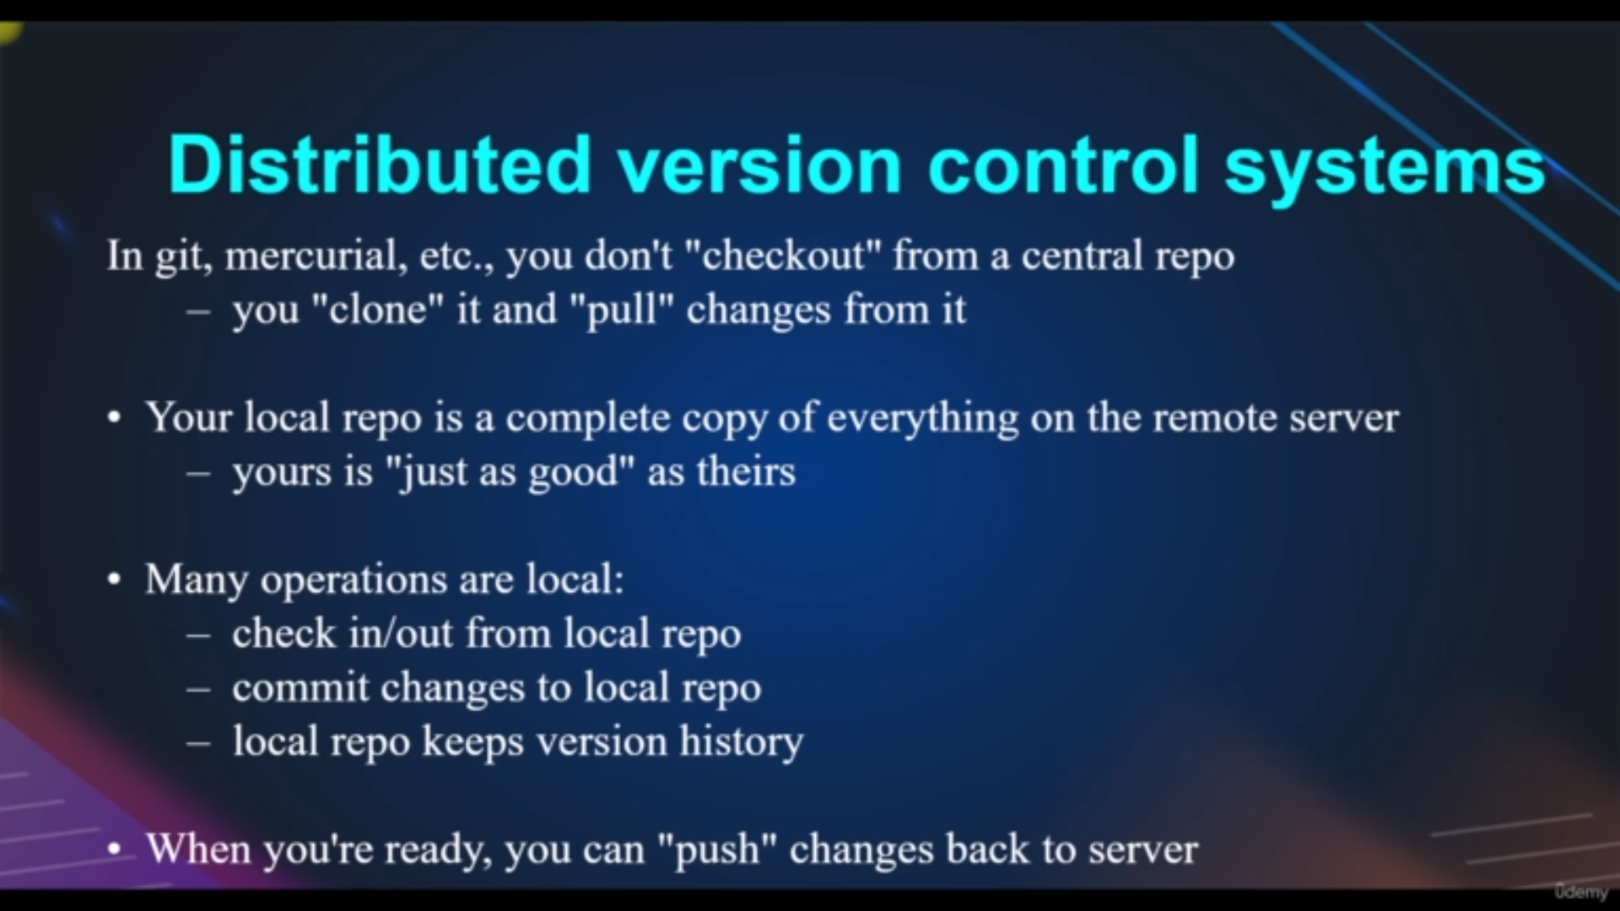uses of DVS

flow of Dvs

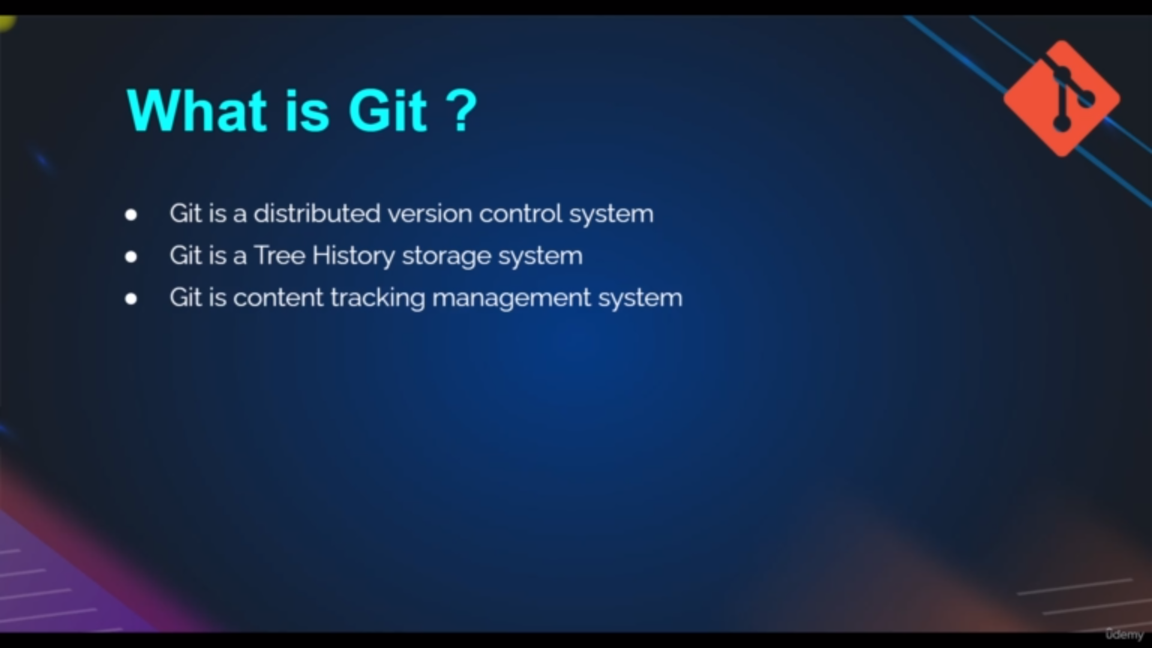Git definition

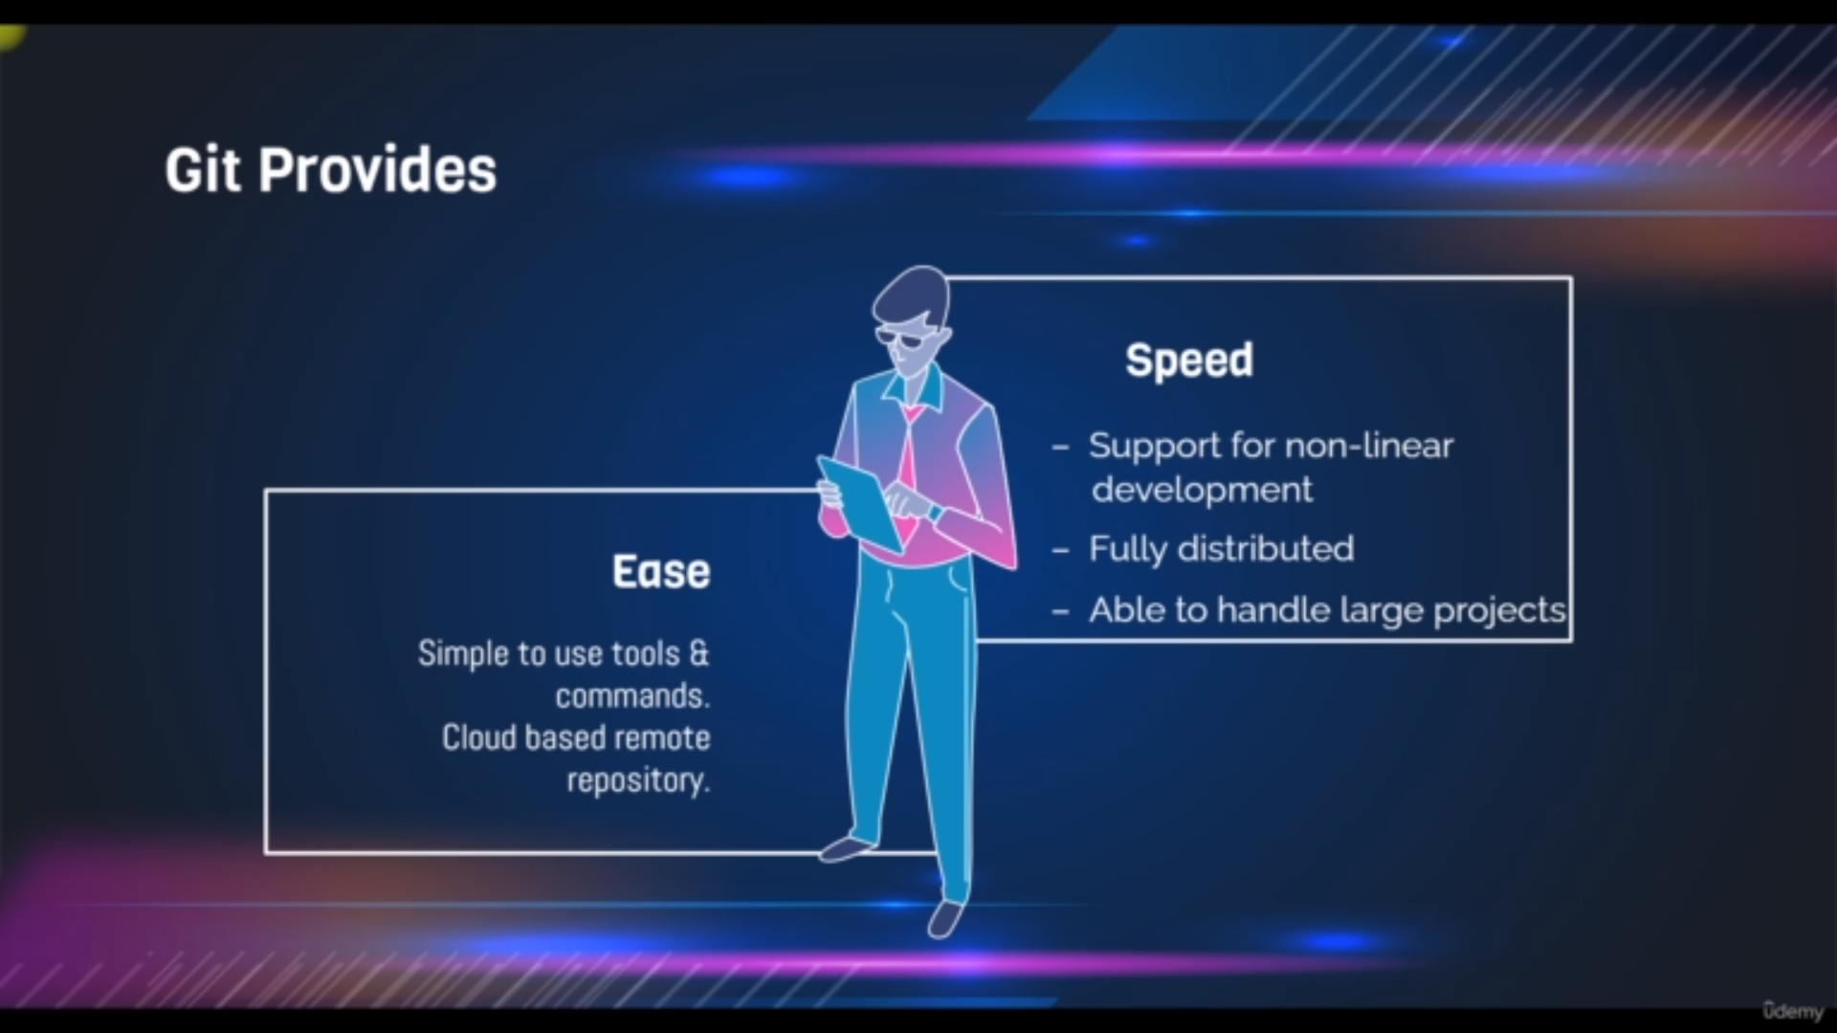uses of git

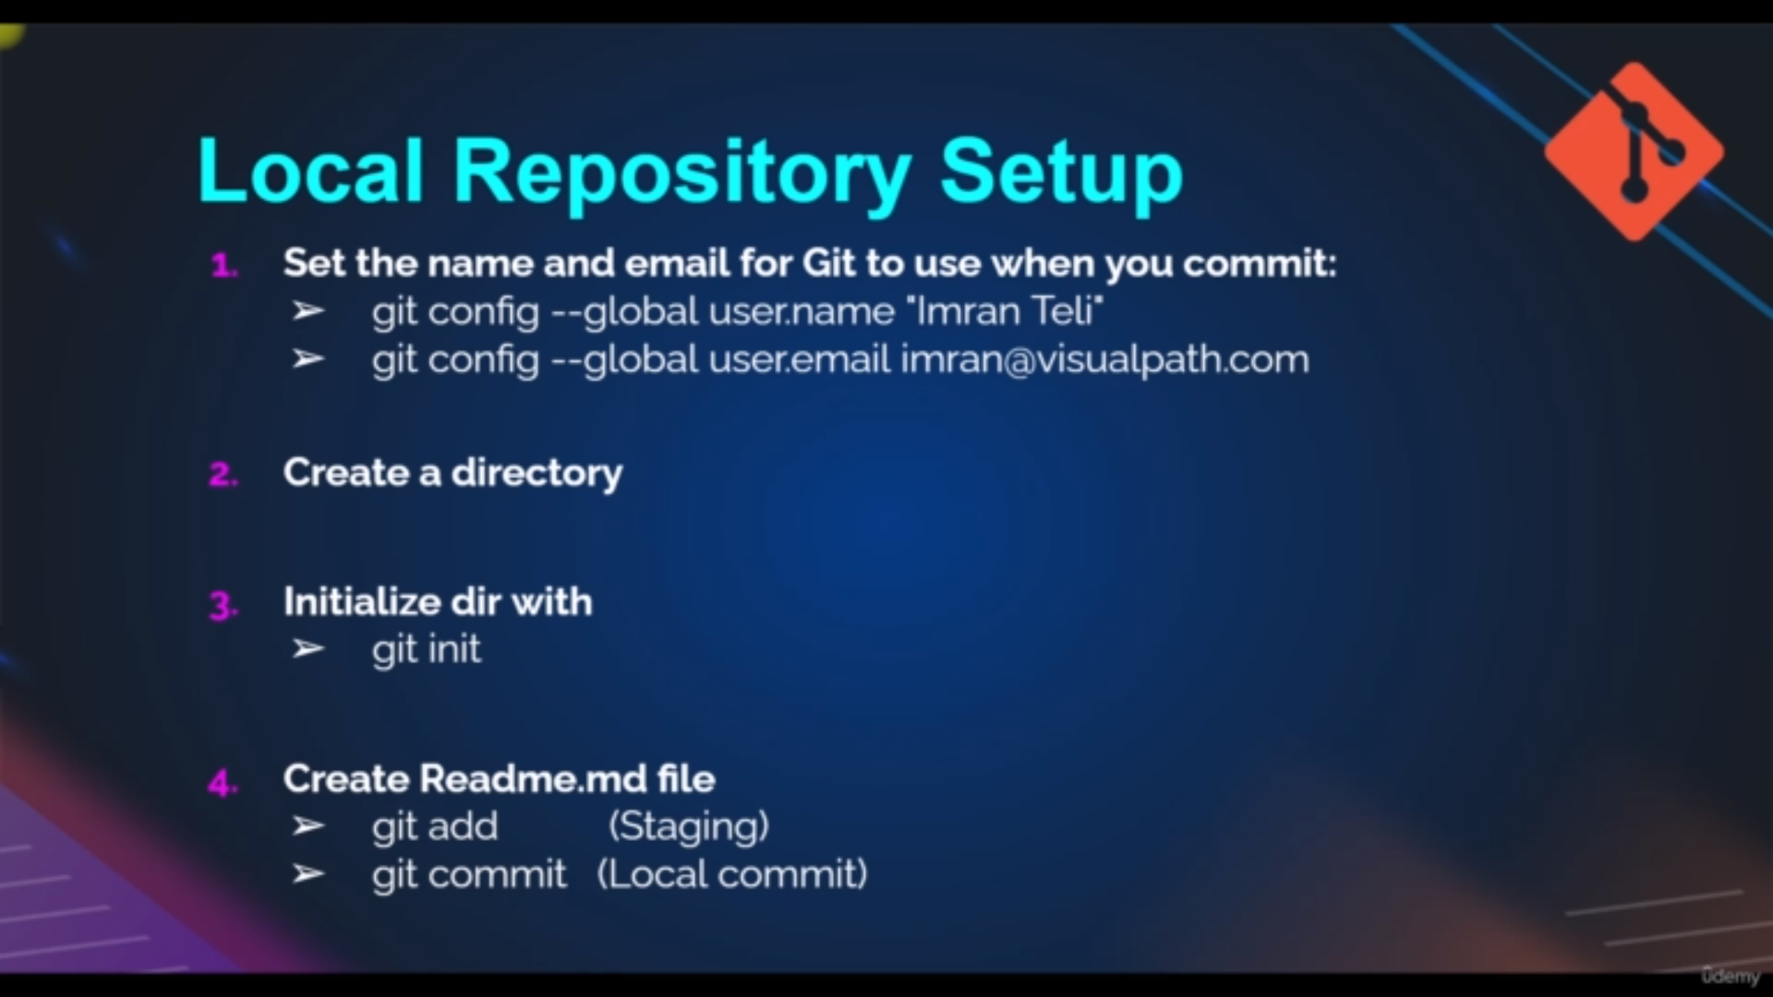steps to do in local repositerey

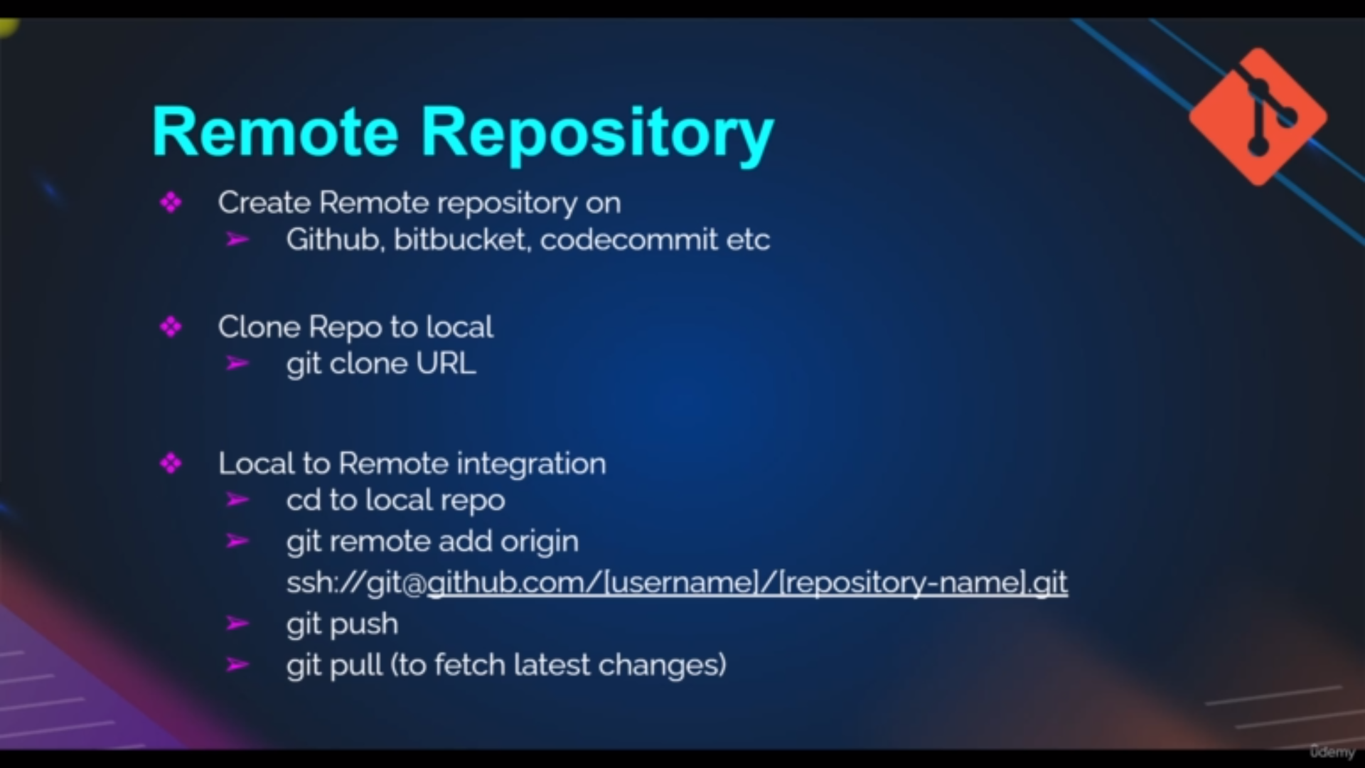steps to do for attach local to remote repositery

Commands:

after installing git

**c1:**To set the our user namd and email for our local repositery

**git config –-global user.name “name”**

**git config –-global user.email “email”**

it will set the local repositery as above credentials by this we can track which user made changes

**c2:**for git to track fiile we must initialize the git

**git init**

it has all configuration for what to do git

**c3:** to know what is state of repositery we have to use

**git status**

**c4:**if we git status command show untracked files we have to use this commands

**git add .**

It will tell the git that these files are added or changed and tell the git these files to to be committed

**c5:**if we command c4 we will get the git status as files to committed then

**git commit -m "m1"**

it will commit the files I.e it add the files to local repository with message m1

**c5:**to show the logs

**git log**

each log have the commits and with commitid

**git log –oneline**

it shows the logs commitid in simple way

**c6:** to show what are commits changed like what we changed in file

git show “**commitid**”

commitid is found in **c5** command

**c7:**to attach our local repo with remote repository

**git remote add origin “url”**

url can find in github repo after log into github click on your repo→ click on code→

copy that url and paste it

**c8:** to create branch

**git branch -M main**

it will create banch with branchname “main”

**c9**:to add the local repo file to remote repo files

**git push -u origin main**

it will add the code to remote repo in main branch

after excuting the command you have to enter username and after that you have to

enter the token

token can be find in

step1:click github dp→click on setting→ click on developer settings→ click on personalacces tokens→ classic token

then click on create token and writes name and check all tokens

**Branches:**

In git we use branches to do not disturb the actual stable code

for example we 4 four developer and they follow agile process

four devs has their own braches to commit other than we have main branch which has stable code or main code

So these devs develop new features and commit the code to theire own branch until

the sprint end

In the sprint all dev code or features are reviewed and given with +1 and +2 if the code is stable

After this the code is merged with main branch

**c10**: to create normal branch

**git branch -c s1[branch name]**

**c11:** to switch from one branch to another branch

**git checkout s1**

**or**

**git switch main**

**c12:** to remove the files and git to unbranch that files

**git rm b1**

**c13:**to add the files of sprint branch to main brain branch [we must be in main branch for executing this command]

**git merge s1[branch name]**

**c14:** to ignore some file by git we have to add that file extension or files to

.gitignore file

**vim .gitignore**

for example to ignore all text file by git

add

**\*.txt**

in that .gitignore file

**c15:** to show braches

**git branch**

we will get **\*** mark it currently we are on that branch

**RollBack:**

roll back is to go to the previous version and unsaving the recently edited files

**From Unstaging area:**

**c16:** to check what changes we did

**git diff**

**c17:** rollback from unstaging area

**git checkout a1**

**From Staging Area:**

**c18:** to check what changes we did

**git diff --cached**

**c17:** rollback from unstaging area

**git restore --staged a1[a1:filename]**

**From Committed area:**

**c19:** to check what changes we did

**git diff commitid1..commitid2**

**example:**

git diff f6b17d0..b786fb1

**c20:** rollback from unstaging area

**git revert HEAD**

This command is worked as another commitid it means we will get another commitd

it means it maintaines the history

**c21:for not maintain history we ll use another command**

**git reset --hard commitid**

example:

git reset --hard b786fb1

By this until the mention commitid all commit id are removed

**Connecting Through SSH**

http request is no safer becos some one can hack

ssh is more safer for that

**c22**:Generate public and private key

**ssh-keygen.exe**

it will create .ssh folder where we have public and privare keyfiles

open public key file and copy the content

Go to the github repo click on dp→ click on setting→ click on ssh and GPG keys→click on add new key→ write the title and paste the public on key section→ click on add ssh key

Note:do not copy and paste private key

Then Come to your repository and click on code and copy **ssh url**

**c23:** clone the repository

**git clone sshurl**

then the whole repository is copied to our local repository